Home
About Temple
Events
Pooja Services
Membership
Donate
Volunteer
Contact

Address 4 Upper Denmark Street Limerick | Reg No: 787765
please use info@hindutemple.ie as our official email ID
please change all buddha kind of photos with Indian temples and gods
architectural images, timeline, and progress updates.
remove the following section all the way down till thank you
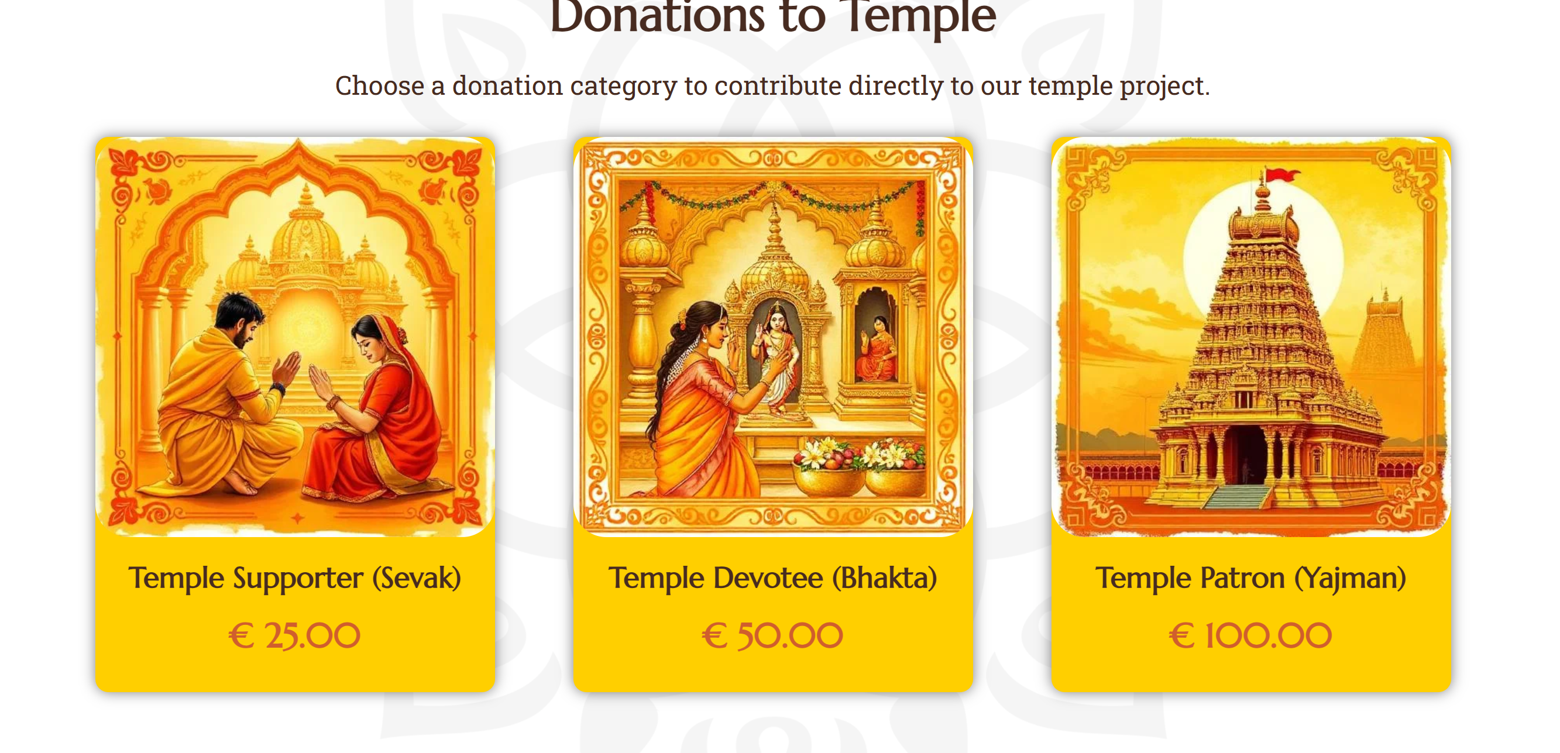
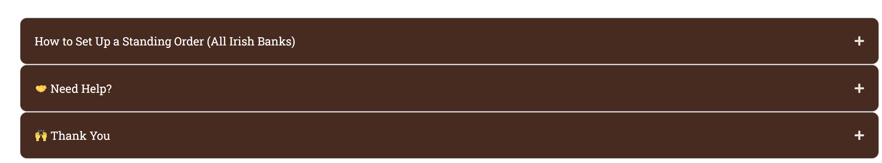

Upcoming should have only upcoming events as per our list
Events section will have all the past events and phots of the same – please use our facebook / insta for photos
Please remove the following
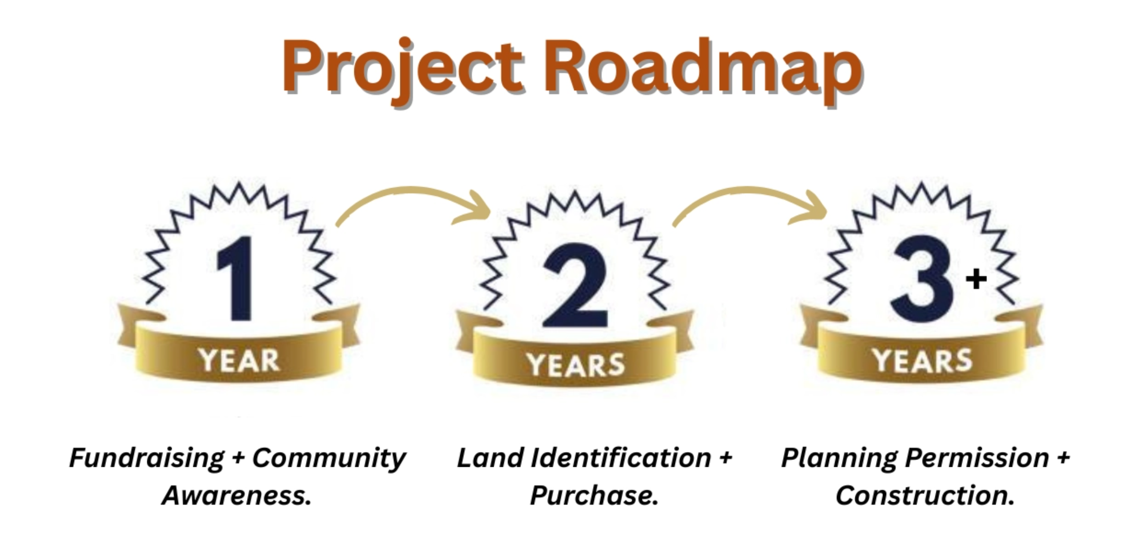
Change our team into Temple Committee Board –similar to the following
https://www.hindutemple.org.nz/trust-team/
also below that please add Operational Committee – 11 members including ladies

Join Our Temple Community
Building Our Temple, Building Our Community
By becoming a member, you support the creation of a permanent Hindu Temple and Cultural Centre in Limerick – a place of worship, culture, and community for present and future generations.
Annual Membership
€20 per year (Stripe button for one time fee)
Your membership helps establish and sustain the temple and its activities while connecting your family to the growing Hindu community in Ireland.
Membership Spiritual Benefits
- 🪔 Monthly Nama–Nakshatra Archana for your family
- 🪔 One Special Occasion Archana each year (birthday, anniversary, new home, etc.)
- 🌳 Karpaga Vriksham Recognition – Member families will be honoured in the new temple through the Karpaga Vriksham installation, where each family’s name and thumb impression will be represented as a leaf, symbolising their contribution to the temple.
Monthly Contribution
We kindly invite you to support the development of the Hindu Cultural & Spiritual Centre in Limerick by selecting one of the monthly contribution options below.
Your support will help us build a permanent space for:
- Religious services and poojas
- Cultural education for children
- Community gatherings and festivals
- Spiritual programs for future generations
Monthly Contribution Options – (Recurring payment using stripe from next month)
- Shraddha Donor – €22 per month
- Seva Donor – €35 per month
- Bhakti Donor – €50 per month
- Custom Contribution – €____ per month
once the member complete the membership by paying the membership fee as per above they will get a welcome email from HAI email as per below

Subject: Welcome to the Hindu Association of Ireland Community!
Email Body:
Dear Member Name,
Om Shree Ganeshaya Namah
We are delighted to welcome you to the Hindu Association of Ireland (HAI) community! Thank you for becoming a member and supporting the development of our temple and cultural initiatives. Your contribution helps us build a permanent place of worship, a hub for cultural and spiritual learning, and a vibrant community for generations to come.
As a valued member, you will enjoy:
- 🪔 Monthly Nama–Nakshatra Archana for your family
- 🪔 One Special Occasion Archana per year (birthday, anniversary, new home, etc.)
- 🌳 Recognition on the Karpaga Vriksham installation in the new temple, where your family’s name and thumb impression will be represented as a leaf
- 💛 Updates on temple events, festivals, and community programs
If you have opted for monthly donations, your ongoing support will directly help us build the Hindu Cultural & Spiritual Centre in Limerick, enabling spiritual, cultural, and educational programs for our community.
We invite you to stay connected:
- Visit our website for updates on events, poojas, and volunteering opportunities
- Follow us on [Social Media Links] for photos and announcements
- Share your ideas and suggestions with us anytime
Once again, thank you for joining our community and for supporting the HAI mission. Together, we are creating a spiritual, cultural, and social home for all Hindu families in Ireland.
With blessings and gratitude,
Team HAI

Refer few other website for inspiration – and ask them not to replicate what is in our current website rather please add their own creative and make it better. Our website is done using website builder so not great.
https://www.hindutemple.org.nz/trust-team/
https://radhadesh.com/
https://www.venkateswara.org.uk/

